**Lab – Design a Prototype of an AI Application**

1. **Objectives**

**Part 1: Consider an IoT Application with AI/ML Technology**

**Part 2: Design Components Required for an IoT Application with AI/ML Technology**

**Part 3: Describe the Process and Operation for the IoT Application with Flowcharts**

1. **Background / Scenario**

With IoT devices and IoT networks getting popular, technologies for IoT devices are also improving rapidly. IoT devices are no longer limited to sensors and actuators; they may have the capability to think and act accordingly according to environment changes, thanks to the development of artificial intelligence (AI) and machine learning (ML). This lab is designed as a group project. The ideal group size is 3 to 4 people.

1. **Required Resources**

Device with internet access

1. **Consider an IoT Application with AI/ML Technology**

In Part 1, the group members will list the functions and features of a smart home thermostat and controller device with capability of self-learning, making decisions based on the environment changes, and acting accordingly.

* 1. **List the desired features and function for such a device.**

**Có thể đọc thông số nhiệt độ môi trường xung quanh, thông qua việc học hỏi và đưa ra quyết định thích hợp tùy theo nhiệt độ trong nhà. VD: Tự động bật máy điều hòa khi nhiệt độ cao để làm giảm nhiệt độ…**

Hint: how to give command?

* 1. **List the factors that may influence the perception of temperature.**

Số lượng người trong phòng

Các thiết bị điện tử tạo nhiệt trong nhà

Màu sắc của phòng

Điều kiện môi trường bên ngoài

* 1. **List the ways the smart device can get information about those factors.**

Hành vi của người dùng, các thiết bị cảm biến trong nhà…

1. **Design components required for the device with AI/ML Technology**

In Part 2, the group will explore and design the functions of the key components required for the smart thermostat/controller.

* 1. **What are the key components for a smart thermostat/controller?**

Cảm biến, bộ điều khiển và thiết bị điều khiển

* 1. **List the process and operation of the smart thermostat/controller?**

**Cảm biến**: Là một dạng cảm biến để đo lường các giá trị thực cũng như kiểm soát và kiểm tra nhiệt độ, độ ấm, lưu lượng… đồng thời cũng cho ra những thông tin đến bộ điều khiển.

**Bộ điều khiển**: Khi nhận được tín hiệu từ cảm biến nó sẽ bắt đầu xử lí tín hiệu vào và sau đó nó sẽ xuất tín hiệu tới thiết bị kiểm soát.

**Thiết bị điều khiển**: Sẽ thực hiện theo đúng chỉ đạo của bộ điều khiển đã cung cấp trước đó.

1. **Describe the Process and Operation for the IoT Application with a Flowchart**

In Part 3, the group will use flowcharts to describe the logic flow for data collection, data analysis, human being interaction, and taking proper actions.

* 1. **Using a flowchart, describe how data is collected, communicated to the AI/ML application in the cloud computing, and processed.**

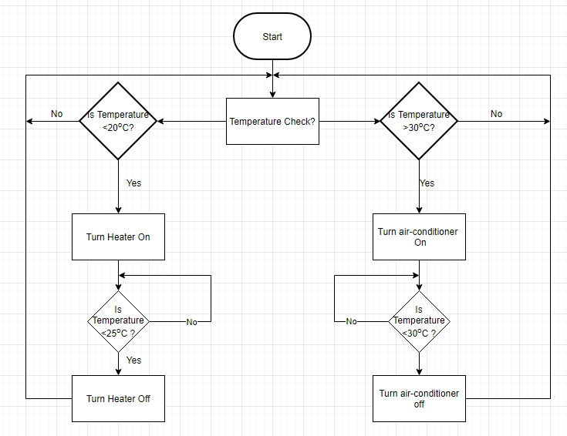

* 1. **Using a flowchart to illustrate the general operation of the smart thermostat/controller**

__________________________________________________________________________________

__________________________________________________________________________________

__________________________________________________________________________________

1. **Reflection**
   1. Which component provides the brain power for the learning and then adjusting accordingly?

_______________________________________________________________________________________

* 1. Can you think of other IoT devices that will learn over time and improve their operations?

_______________________________________________________________________________________